8.0 HSD-U 604-356-04 1732-A 5445
HSD-U 612-073-00 1732-A 5445
PowerBoard 608-808-01 1732-A 5445
ChanBoard0 613-493-05 1732-A 5445
ChanBoard1 613-493-05 1732-A 5445
12.0 HSD-U 604-356-04 1609-A 5445
HSD-U 612-073-00 1508-A 5445
PowerBoard 608-808-01 1148-A 5445
ChanBoard0 613-493-05 1609-A 5445
ChanBoard1 613-493-05 1609-A 5445
16.0 HSD-U 604-356-04 1609-A 5445
HSD-U 612-073-00 1508-A 5445
PowerBoard 608-808-01 1148-A 5445
ChanBoard0 613-493-05 1609-A 5445
ChanBoard1 613-493-05 1609-A 5445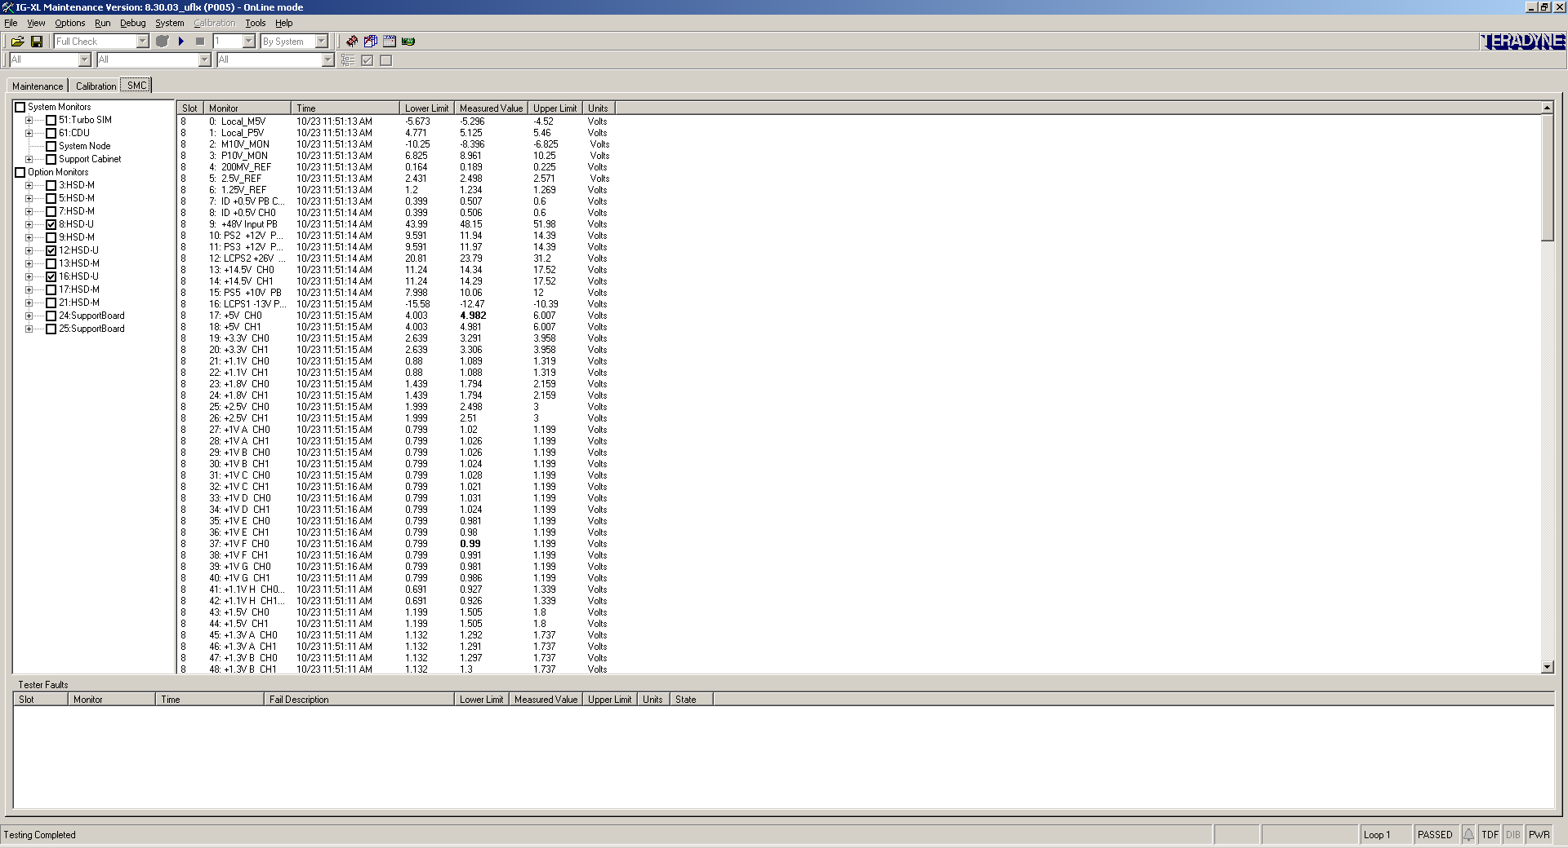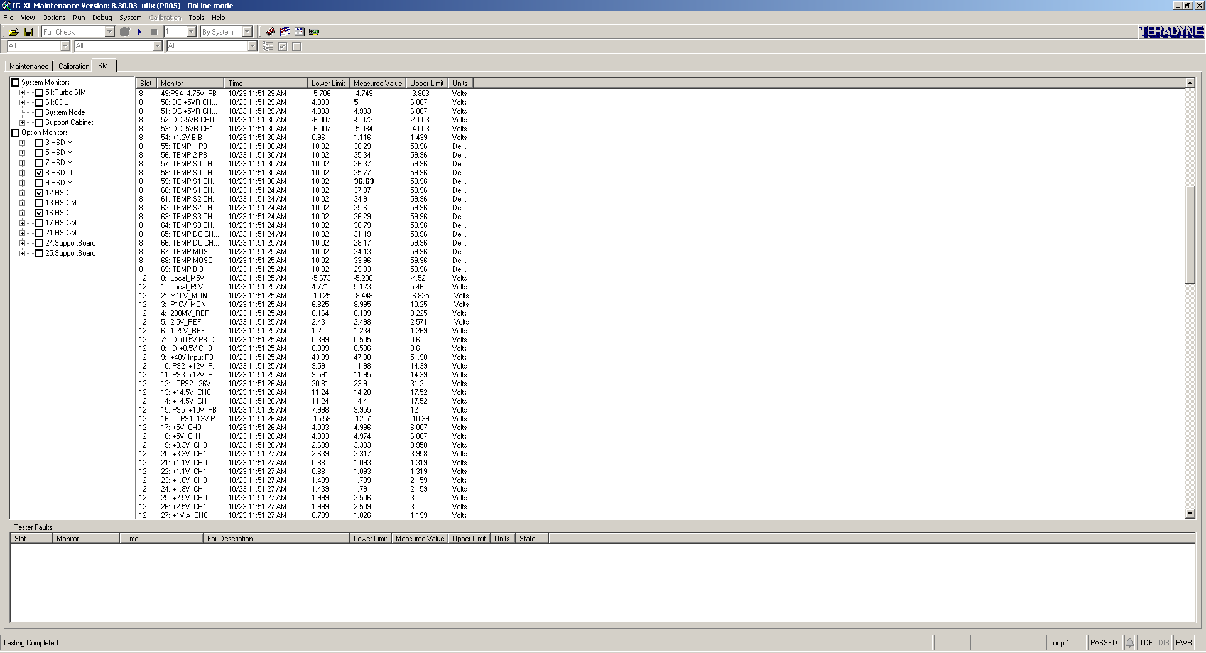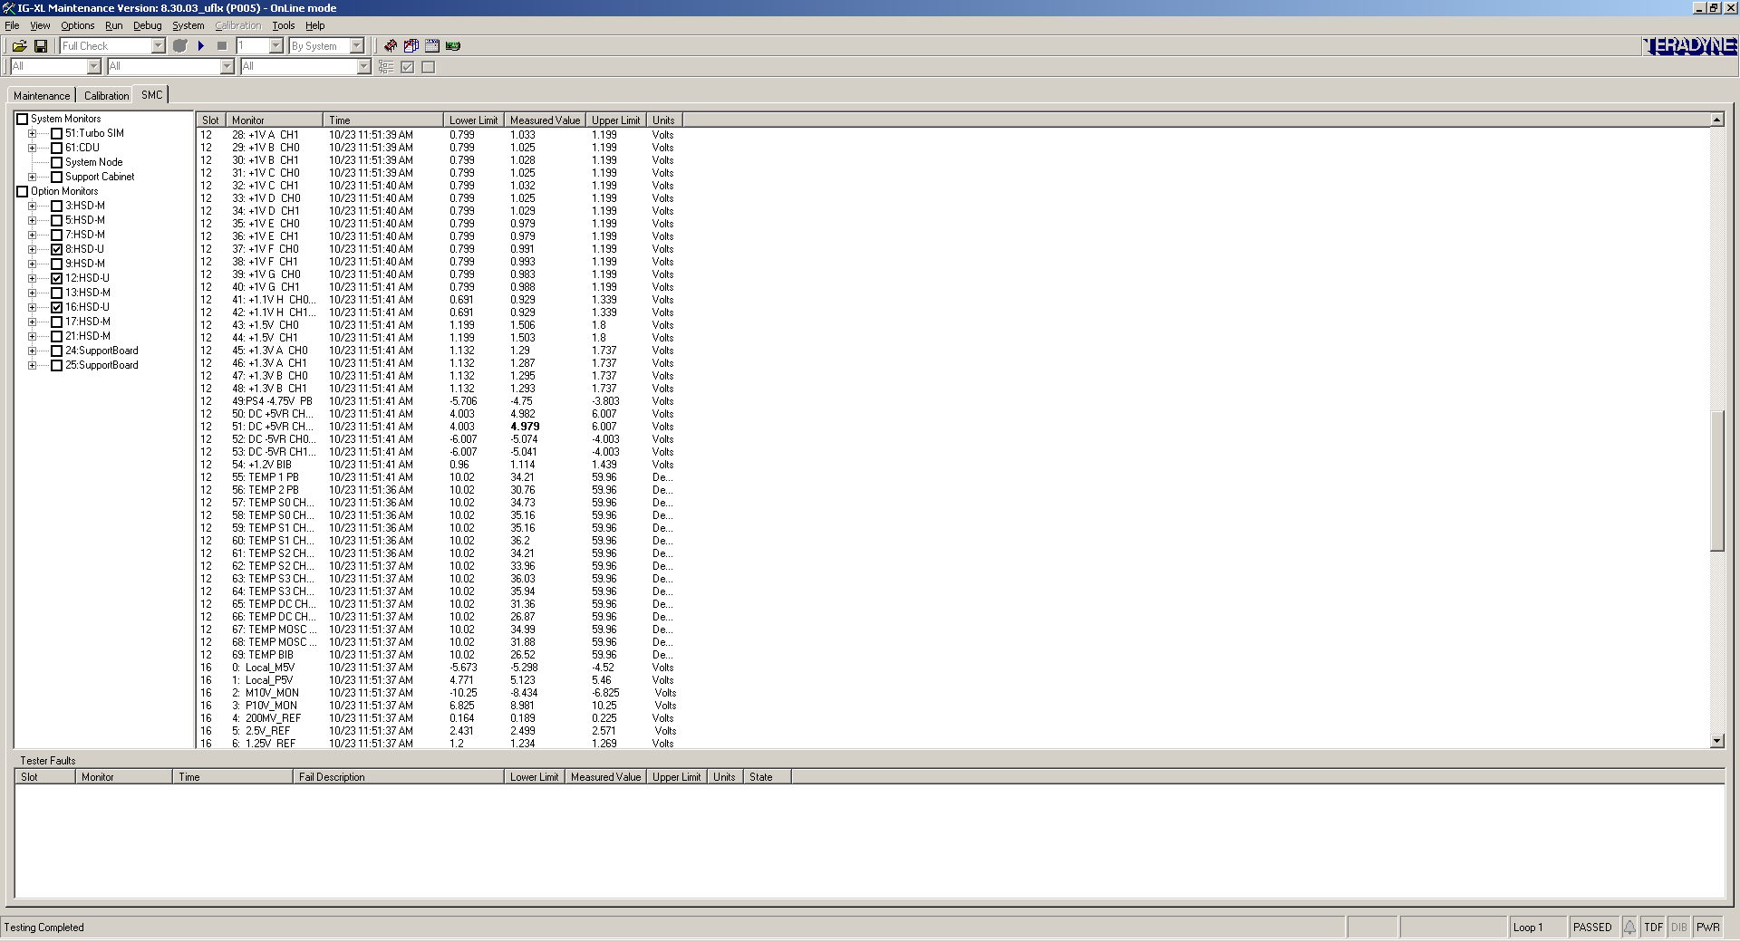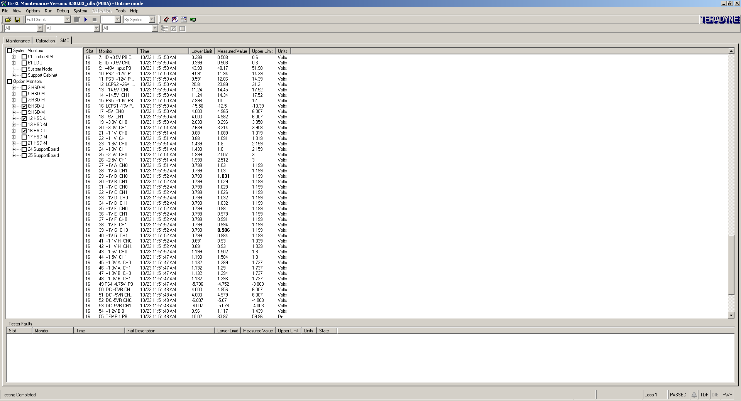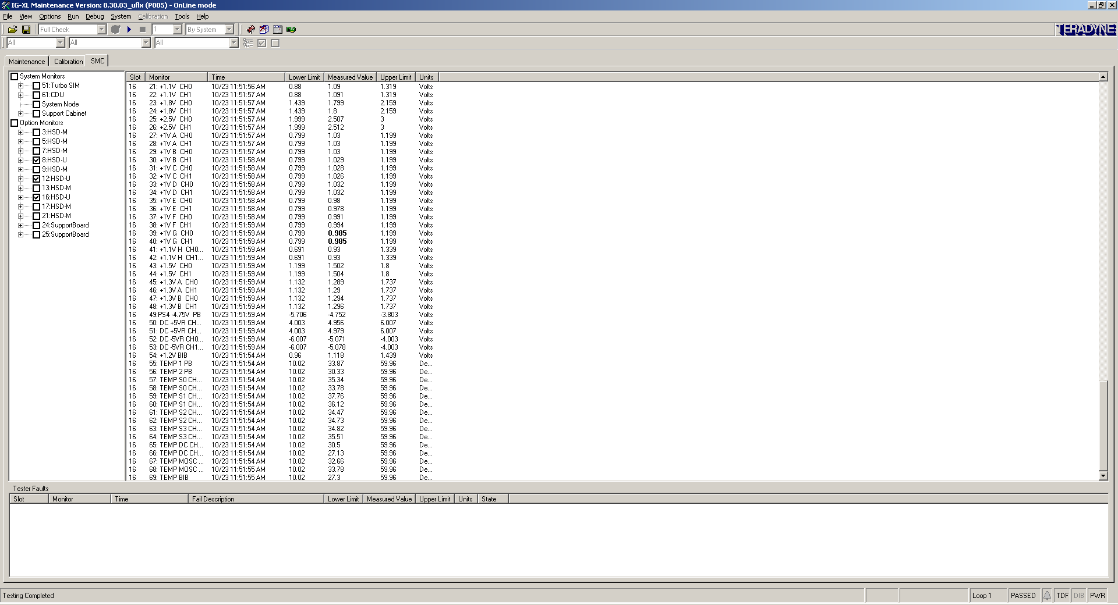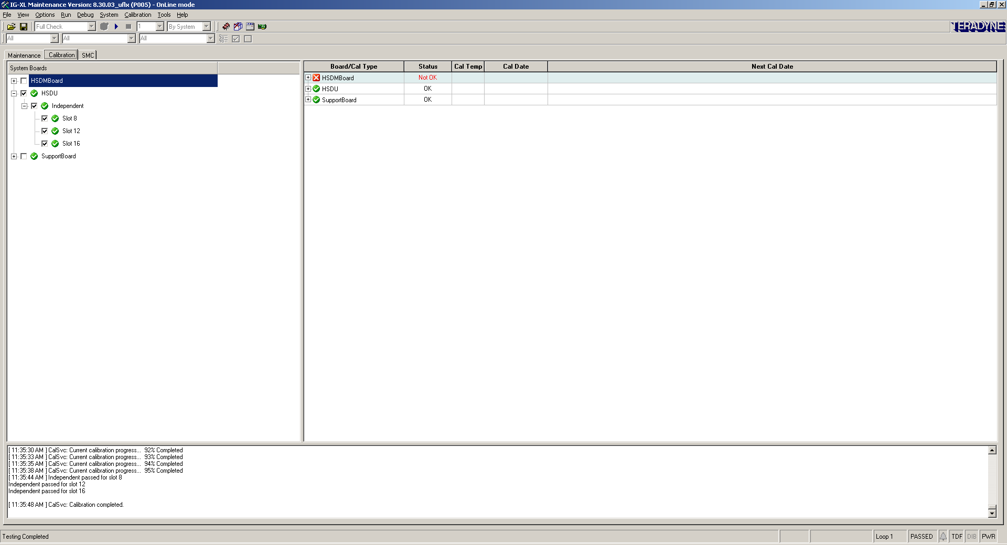[ 11:30:00 AM ] CalSvc: Calibrating SupportBoard...

[ 11:30:00 AM ] CalSvc: Started calibration... 1% Completed
[ 11:30:04 AM ] DCInt passed for slot 24

[ 11:30:05 AM ] CalSvc: Calibration completed.
[ 11:30:06 AM ] Starting to Calibrate....
[ 11:30:06 AM ]
[ 11:30:06 AM ] CalSvc: Performing calibration for SupportBoard
[ 11:30:06 AM ] CalSvc: Started calibration... 1% Completed
[ 11:30:11 AM ] DCInt passed for slot 24

[ 11:30:11 AM ] CalSvc: Calibration completed.
[ 11:30:22 AM ] Starting to Calibrate....
[ 11:30:22 AM ]
[ 11:30:23 AM ] CalSvc: Performing calibration for HSD-U
[ 11:30:23 AM ] CalSvc: Started calibration... 1% Completed
[ 11:30:50 AM ] CalSvc: Current calibration progress... 1% Completed
[ 11:30:55 AM ] CalSvc: Current calibration progress... 2% Completed
[ 11:30:58 AM ] CalSvc: Current calibration progress... 3% Completed
[ 11:31:04 AM ] CalSvc: Current calibration progress... 4% Completed
[ 11:31:07 AM ] CalSvc: Current calibration progress... 5% Completed
[ 11:31:12 AM ] CalSvc: Current calibration progress... 6% Completed
[ 11:31:14 AM ] CalSvc: Current calibration progress... 7% Completed
[ 11:31:17 AM ] CalSvc: Current calibration progress... 8% Completed
[ 11:31:22 AM ] CalSvc: Current calibration progress... 9% Completed
[ 11:31:26 AM ] CalSvc: Current calibration progress... 10% Completed
[ 11:31:31 AM ] CalSvc: Current calibration progress... 11% Completed
[ 11:31:35 AM ] CalSvc: Current calibration progress... 12% Completed
[ 11:31:41 AM ] CalSvc: Current calibration progress... 13% Completed
[ 11:31:44 AM ] CalSvc: Current calibration progress... 14% Completed
[ 11:31:49 AM ] CalSvc: Current calibration progress... 15% Completed
[ 11:31:53 AM ] CalSvc: Current calibration progress... 16% Completed
[ 11:31:56 AM ] CalSvc: Current calibration progress... 17% Completed
[ 11:31:59 AM ] CalSvc: Current calibration progress... 18% Completed
[ 11:32:02 AM ] CalSvc: Current calibration progress... 19% Completed
[ 11:32:05 AM ] CalSvc: Current calibration progress... 20% Completed
[ 11:32:08 AM ] CalSvc: Current calibration progress... 21% Completed
[ 11:32:11 AM ] CalSvc: Current calibration progress... 22% Completed
[ 11:32:15 AM ] CalSvc: Current calibration progress... 23% Completed
[ 11:32:24 AM ] CalSvc: Current calibration progress... 24% Completed
[ 11:32:27 AM ] CalSvc: Current calibration progress... 25% Completed
[ 11:32:32 AM ] CalSvc: Current calibration progress... 26% Completed
[ 11:32:34 AM ] CalSvc: Current calibration progress... 27% Completed
[ 11:32:37 AM ] CalSvc: Current calibration progress... 28% Completed
[ 11:32:40 AM ] CalSvc: Current calibration progress... 29% Completed
[ 11:32:43 AM ] CalSvc: Current calibration progress... 30% Completed
[ 11:32:46 AM ] CalSvc: Current calibration progress... 31% Completed
[ 11:32:49 AM ] CalSvc: Current calibration progress... 32% Completed
[ 11:32:51 AM ] CalSvc: Current calibration progress... 33% Completed
[ 11:32:54 AM ] CalSvc: Current calibration progress... 34% Completed
[ 11:32:57 AM ] CalSvc: Current calibration progress... 35% Completed
[ 11:32:59 AM ] CalSvc: Current calibration progress... 36% Completed
[ 11:33:02 AM ] CalSvc: Current calibration progress... 37% Completed
[ 11:33:05 AM ] CalSvc: Current calibration progress... 38% Completed
[ 11:33:07 AM ] CalSvc: Current calibration progress... 39% Completed
[ 11:33:10 AM ] CalSvc: Current calibration progress... 40% Completed
[ 11:33:13 AM ] CalSvc: Current calibration progress... 41% Completed
[ 11:33:15 AM ] CalSvc: Current calibration progress... 42% Completed
[ 11:33:18 AM ] CalSvc: Current calibration progress... 43% Completed
[ 11:33:21 AM ] CalSvc: Current calibration progress... 44% Completed
[ 11:33:23 AM ] CalSvc: Current calibration progress... 45% Completed
[ 11:33:26 AM ] CalSvc: Current calibration progress... 46% Completed
[ 11:33:29 AM ] CalSvc: Current calibration progress... 47% Completed
[ 11:33:32 AM ] CalSvc: Current calibration progress... 48% Completed
[ 11:33:34 AM ] CalSvc: Current calibration progress... 49% Completed
[ 11:33:37 AM ] CalSvc: Current calibration progress... 50% Completed
[ 11:33:40 AM ] CalSvc: Current calibration progress... 51% Completed
[ 11:33:43 AM ] CalSvc: Current calibration progress... 52% Completed
[ 11:33:45 AM ] CalSvc: Current calibration progress... 53% Completed
[ 11:33:48 AM ] CalSvc: Current calibration progress... 54% Completed
[ 11:33:51 AM ] CalSvc: Current calibration progress... 55% Completed
[ 11:33:54 AM ] CalSvc: Current calibration progress... 56% Completed
[ 11:33:56 AM ] CalSvc: Current calibration progress... 57% Completed
[ 11:33:59 AM ] CalSvc: Current calibration progress... 58% Completed
[ 11:34:02 AM ] CalSvc: Current calibration progress... 59% Completed
[ 11:34:04 AM ] CalSvc: Current calibration progress... 60% Completed
[ 11:34:07 AM ] CalSvc: Current calibration progress... 61% Completed
[ 11:34:10 AM ] CalSvc: Current calibration progress... 62% Completed
[ 11:34:12 AM ] CalSvc: Current calibration progress... 63% Completed
[ 11:34:15 AM ] CalSvc: Current calibration progress... 64% Completed
[ 11:34:18 AM ] CalSvc: Current calibration progress... 65% Completed
[ 11:34:20 AM ] CalSvc: Current calibration progress... 66% Completed
[ 11:34:23 AM ] CalSvc: Current calibration progress... 67% Completed
[ 11:34:26 AM ] CalSvc: Current calibration progress... 68% Completed
[ 11:34:29 AM ] CalSvc: Current calibration progress... 69% Completed
[ 11:34:31 AM ] CalSvc: Current calibration progress... 70% Completed
[ 11:34:34 AM ] CalSvc: Current calibration progress... 71% Completed
[ 11:34:37 AM ] CalSvc: Current calibration progress... 72% Completed
[ 11:34:39 AM ] CalSvc: Current calibration progress... 73% Completed
[ 11:34:42 AM ] CalSvc: Current calibration progress... 74% Completed
[ 11:34:45 AM ] CalSvc: Current calibration progress... 75% Completed
[ 11:34:47 AM ] CalSvc: Current calibration progress... 76% Completed
[ 11:34:50 AM ] CalSvc: Current calibration progress... 77% Completed
[ 11:34:53 AM ] CalSvc: Current calibration progress... 78% Completed
[ 11:34:55 AM ] CalSvc: Current calibration progress... 79% Completed
[ 11:34:58 AM ] CalSvc: Current calibration progress... 80% Completed
[ 11:35:01 AM ] CalSvc: Current calibration progress... 81% Completed
[ 11:35:03 AM ] CalSvc: Current calibration progress... 82% Completed
[ 11:35:06 AM ] CalSvc: Current calibration progress... 83% Completed
[ 11:35:09 AM ] CalSvc: Current calibration progress... 84% Completed
[ 11:35:11 AM ] CalSvc: Current calibration progress... 85% Completed
[ 11:35:14 AM ] CalSvc: Current calibration progress... 86% Completed
[ 11:35:17 AM ] CalSvc: Current calibration progress... 87% Completed
[ 11:35:19 AM ] CalSvc: Current calibration progress... 88% Completed
[ 11:35:22 AM ] CalSvc: Current calibration progress... 89% Completed
[ 11:35:25 AM ] CalSvc: Current calibration progress... 90% Completed
[ 11:35:27 AM ] CalSvc: Current calibration progress... 91% Completed
[ 11:35:30 AM ] CalSvc: Current calibration progress... 92% Completed
[ 11:35:33 AM ] CalSvc: Current calibration progress... 93% Completed
[ 11:35:35 AM ] CalSvc: Current calibration progress... 94% Completed
[ 11:35:38 AM ] CalSvc: Current calibration progress... 95% Completed
[ 11:35:44 AM ] Independent passed for slot 8
Independent passed for slot 12
Independent passed for slot 16

[ 11:35:48 AM ] CalSvc: Calibration completed.

